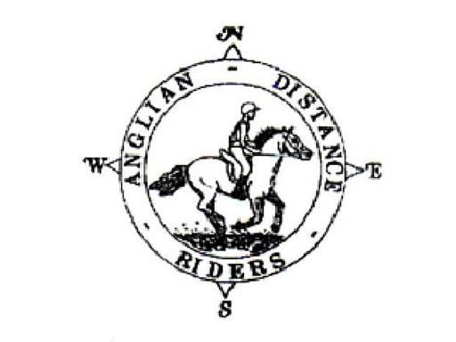

AGM
Saturday 8th December
Bardwell Village Hall Bardwell 6.30pm
followed by a celebration supper and annual prize giving.
Please return the below slip by 25th November, stating your food preference to Frances Alford, 2 Cornwallis Close, West Stow,
Bury St Edmunds, Suffolk IP28 6EU
As always, raffle prizes are gratefully received.
Please bring your own drinks and glasses.

Name: …………………………………………………….
Chicken Curry & Rice
Steak & Ale Pie with vegetables and potatoes
Mushroom Stroganoff & Rice
Sticky toffee pudding and cream
Apple and Mincemeat Crumble with cream

If you have any dietary requirements, please list them below:

I enclose a cheque of £15 per head payable to ADR

