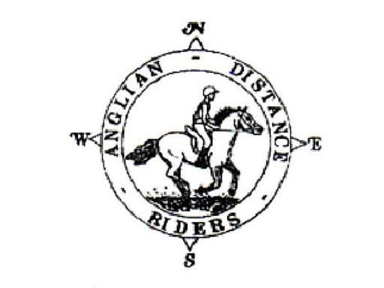

ANGLIAN DISTANCE RIDERS
Catch Up Ride 27th October 2019
Emilys Wood, Brandon FR 24

- Riders to Start between 10am & noon
- Horses must be 4 years old or over. An adult must accompany juniors aged between 8 and 13. A hard hat of PAS 015, VGI 01.040 (2014-12), SNELL E2001, SNELL E2016, AS/ZS 3838 (2006 onwards) or ASTM/SEI standard must be worn. Competitors may not ride in wellington boots and whips may not exceed 30” in length. Spurs and draw reins or similar are not permitted. Cyclists may not accompany riders.
- The organisers, stewards, helpers & landowners cannot accept liability for accidents, damage, injury or illness to competitors, spectators or any other person, property, servants, animals or horses/ponies in connection with or arising out of this ride. All competitors & person’s attending the ride do so at their own risk. It shall be a condition of entry that each entrant shall indemnify the organisers against any legal action arising from any accidents or incidents whatsoever. Non-members must have their own third party liability insurance to the value of £5,000,000. By signing this form you accept these terms and conditions, recognizing that this is a Risk Sport and confirming that you have the competence to undertake the class you are entering.
- A copy of the rules will be on display at the ride or can be obtained from the website: http://angliandistanceriders.co.uk/index.php/ride-dates/ride-rules/
- All Junior Riders must have a signed Parental Consent form lodged with the Ride Organiser at the start of the ride. The Form is available from the Ride Dates page on the website.
- Due to the recent flu outbreak ADR has had to rethink our ride entries and make a few changes. Until further notice we will be requiring a copy of the vaccination card along with your entry for every horse participating in our rides. All vaccinations must be fully up to date, and if a booster or second vaccination is required, it must have been given a full 7 days before the ride.
If the vaccination copy is not received with your ride entry, or shown to the parking steward on arrival, entry will be refused and you will be unable to participate in our rides. This is to safe guard us all and I am sure we have your support and co-operation.

Entry Fees Per day | Adult Members | Junior Members | Adult Non-Members | Junior Non-Members
BEFORE closing date | £15 | £5 | £20 | £15
AFTER closing date/on the day | £20 | £20 | £25 | £25
Please return completed entry form to: Vikki Roberts, Hall Gardens, Gt Livermere, BSE, IP31 1JR. Email- sorcha1971@hotmail.co.uk
The closing date for this ride is: 21/10/2019

TO BENEFIT FROM THE REDUCED ENTRY FEES, YOUR ENTRY MUST BE WITH THE RIDE ORGANISER BEFORE THE CLOSING DATE! ENTRIES RECEIVED AFTER THIS DATE WILL BE CHARGED AT THE HIGHER FEE.

CATCH UP RIDE 27TH OCTOBER 2019

NAME:……………………………………………………………….…………………………………………….................................…………………….....……………………………….

ADDRESS: ……………………………………………………………………………………………..................................……………………….....…………………………………….

……………………………………………………………………………………………Tel:.................................…………..

D.O.B (if under 18)*:……………………………..

Vehicle Registration Number:....................................... Next of Kin/Emergency Contact: ............................................................

Horse Name:........................................................................................... Horse Age.................................. Mare/Gelding/Stallion

Preferred start time: early / middle / late * please circle First riders to leave at 10am, last rider to be on route by noon.

The ride is 10 miles. A map and ride start times with be posted on the ADR Website

I enclose a cheque for £………………. (Payable to Anglian Distance Riders)

I will check the website for ride details or I enclose a large SAE for ride details or please email details to:

…………………………………………………..

In the event a ride is cancelled on the day of the ride, I confirm I can access the Website or Facebook to check

I confirm that I hold third party public liability insurance (please tick)

Signed …………………………….......................................………………….. ADR Bib No. ………………...

*Please complete a parental consent form and nominated adult to accompany any junior riders (8-13 years) from the ADR Website

PLEASE INCLUDE A COPY OF YOUR HORSE’S VACCINATION CERTIFICATE WITH YOUR ENTRY. IF A COPY IS NOT INCLUDED, THE VACCINATION CERTIFICATE MUST BE SHOWN TO THE PARKING STEWARD ON ARRIVAL.

