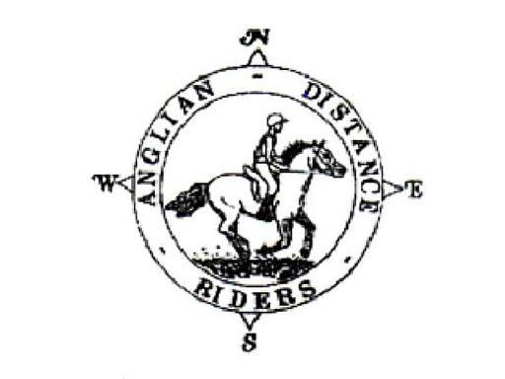
ANGLIAN DISTANCE RIDERS
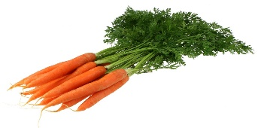
Harvest Lunch Ride
9th October 2021
Hall Farm, Wordwell B1106
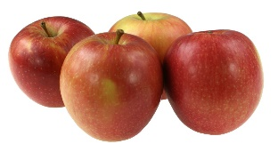
Ride in the glorious Kings Forest followed by a harvest lunch ride for you and your horse
This Photo by Unknown Author is licensed under CC BY-SA

- Riders to Start between 11am & 12.30
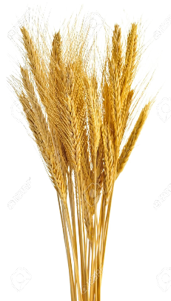
- Horses must be 4 years old or over. An adult must accompany juniors aged between 8 and 13. A hard hat of PAS 015, VGI 01.040 (2014-12), SNELL E2001, SNELL E2016, AS/ZS 3838 (2006 onwards) or ASTM/SEI standard must be worn. Competitors may not ride in wellington boots and whips may not exceed 30” in length. Spurs and draw reins or similar are not permitted. Cyclists may not accompany riders.
- The organisers, stewards, helpers & landowners cannot accept liability for accidents, damage, injury or illness to competitors, spectators or any other person, property, servants, animals or horses/ponies in connection with or arising out of this ride. All competitors & person’s attending the ride do so at their own risk. It shall be a condition of entry that each entrant shall indemnify the organisers against any legal action arising from any accidents or incidents whatsoever. Non-members must have their own third party liability insurance to the value of £10,000,000. By signing this form you accept these terms and conditions, recognizing that this is a Risk Sport and confirming that you have the competence to undertake the class you are entering.
- A copy of the rules will be on display at the ride or can be obtained from the website: http://angliandistanceriders.co.uk/index.php/ride-dates/ride-rules/
- All Junior Riders must have a signed Parental Consent form lodged with the Ride Organiser at the start of the ride. The Form is available from the Ride Dates page on the website.
- Due to the equine flu outbreak and Covid 19. ADR has had to rethink our ride entries and make a few changes. Until further notice we will be requiring a copy of your horses vaccination card along with your entry for every horse participating in our rides. All vaccinations must be fully up to date, and if a booster or second vaccination is required, it must have been given a full 7 days before the ride.
If the vaccination copy is not received with your ride entry, entry will be refused and you will be unable to participate in our rides. This is to safe guard us all and I am sure we have your support and co-operation

Entry Fees to include a harvest lunch | Adult Members | Junior Members | Adult Temp day Riders | Junior Temp day Riders
 | £25 | £15 | £30 | £25

Please return completed entry form to:
Dianne Luke, Rohan, Icklingham Road, West Stow, Bury St.Edmunds IP28 6EY
Tel: 07909843958 Email: dianneluke@hotmail.com
The closing date for this ride is: 6th October
NO ENTRIES ON THE DAY PLEASE.

When entering, non-members are now classed as Temp day riders due to change in insurance!

Harvest Lunch Ride
9th October 2021

NAME:…………………………..

ADDRESS:

…………………………………………………………………………………………… Tel:.........................

D.O.B (if under 18)*:……………………………..

Vehicle Registration Number:........... Next of Kin/Emergency Contact: ………………………………….

Horse Name:..................................................... Horse Age............................. Gelding………………

Preferred start time: Early/Middle/ Late * please circle First riders to leave at 11am, last rider to be on route by 12.30

Routes offered 12 miles or 8.5 miles. A map and ride start times with be posted on the ADR Website

I enclose a cheque for £………………. (Payable to Anglian Distance Riders)

I will pay £………….by BACS with reference **0910HL*

(BACS details - Account Name: Anglian Distance Riders, Sort Code: 20-16-12, Account Number: 43445240)

If you are paying for another rider please specify who………………………..

I will check the website for ride details or I enclose a large SAE for ride details or please email details to:

……………………………………………………………………………………………………….

In the event a ride is cancelled on the day of the ride, I confirm I can access the Website or Facebook to check

I confirm that I hold third party public liability insurance to £10m (please tick)

Signed …………………………….................………………….. ADR Bib No. ………………...

*Please complete a parental consent form and nominated adult to accompany any junior riders (8-13 years) from the ADR Website

PLEASE INCLUDE A COPY OF YOUR HORSE’S VACCINATION CERTIFICATE WITH YOUR ENTRY. IF A COPY IS NOT INCLUDED YOU WILL NOT BE ENTERED.

