​
Anglian Distance Riders
AGM

The Tithe Barn,​
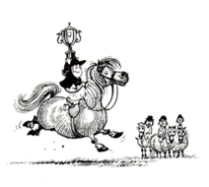
Bardwell, Suffolk
Saturday 4th December
6.00pm

Supper to follow at 7.00pm
Please come and join us for an evening of celebration.

………………………………………………………………………………………………

Name ………………………………………………………………….
I would like ……………….. tickets and the following supper(s)at £20 per head
Beef casserole in red wine
Chicken in a mushroom sauce
Nut Roast
Apple Crumble and Custard
Profiteroles

I enclose a cheque for …………………………..
I will pay by BACS (AGM21) …………………..
Please reserve your place and make your order by Friday 19th November
RSVP to Dianne Luke, Rohan, Icklingham Road, West Stow, Bury St. Edmunds, IP28 6EY
Email dianneluke@hotmail.com

