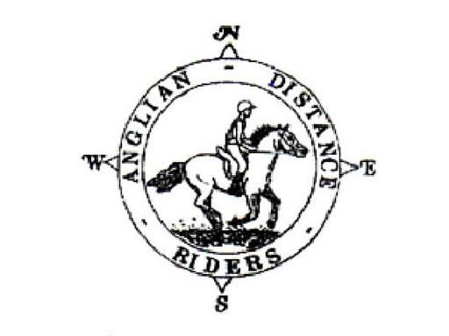

ANGLIAN DISTANCE RIDERS
12th March 2022
Spring Ride, North Stow,Route 210
Just off the B1106

- Riders to Start between 10am & noon
- Horses must be 4 years old or over. An adult must accompany juniors aged between 8 and 13. A hard hat of PAS 015, VGI 01.040 (2014-12), SNELL E2001, SNELL E2016, AS/ZS 3838 (2006 onwards) or ASTM/SEI standard must be worn. Competitors may not ride in wellington boots and whips may not exceed 30” in length. Spurs and draw reins or similar are not permitted. Cyclists may not accompany riders.
- The organisers, stewards, helpers & landowners cannot accept liability for accidents, damage, injury or illness to competitors, spectators or any other person, property, servants, animals or horses/ponies in connection with or arising out of this ride. All competitors & person’s attending the ride do so at their own risk. It shall be a condition of entry that each entrant shall indemnify the organisers against any legal action arising from any accidents or incidents whatsoever. Non-members must have their own third party liability insurance to the value of £10,000,000. By signing this form you accept these terms and conditions, recognizing that this is a Risk Sport and confirming that you have the competence to undertake the class you are entering.
- A copy of the rules will be on display at the ride or can be obtained from the website: http://angliandistanceriders.co.uk/index.php/ride-dates/ride-rules/
- All Junior Riders must have a signed Parental Consent form lodged with the Ride Organiser at the start of the ride. The Form is available from the Ride Dates page on the website.
- Due to the equine flu outbreak and Covid 19. ADR has had to rethink our ride entries and make a few changes. Until further notice we will be requiring a copy of your horses vaccination card along with your entry for every horse participating in our rides. All vaccinations must be fully up to date, and if a booster or second vaccination is required, it must have been given a full 7 days before the ride.
If the vaccination copy is not received with your ride entry, entry will be refused and you will be unable to participate in our rides. This is to safe guard us all and I am sure we have your support and co-operation.
Please read below NEW Covid 19 guidelines for our rides before entering.

Covid 19 Guidelines For Anglian Distance Riders 2022

- Please follow social distancing guidelines set by the government at all times
- Please come to our rides alone unless you require one adult from your household to help for safety reasons
- You may ride with up to 6 people however you must always obey social distance guidelines when doing so
- We have scheduled arrival and start times for our rides so please do not arrive more than thirty minutes early and be ready for your start time!
- All entries must be made online or by post, this can include an emailed photocopy of the completed printed form (Ride organisers email is on entry forms)
- If you are unable to enter through email then please use the post for your entry
- Please make sure a copy of your passport is included with your entry and payment otherwise your entry will not be accepted.
- THERE WILL BE NO ENTRIES ON THE DAY
- Payment can be made using our online bacs transfer using the reference on our entry form or cheque through the post
- All riders must have paid prior to the ride, we will not process your entry until we have received payment
- Time slots are given through a first come first paid basis
- Please still book in with us when you arrive with your rider number
- Have fun and enjoy a bit of normality- 2 metres apart of course!

Entry Fees Per day | Adult Members | Junior Members | Adult Non-Members | Junior Non-Members
BEFORE closing date | £20 | £10 | £25 | £20

Please return completed entry form to:
Vikki Roberts
Hall Gardens , Gt Livermere, BSE , IP31 1JR

Tel: 07940288657
Email: sorcha1971@hotmail.co.uk
The closing date for this ride is: Monday 7th March 2022

NO ENTRIES ON THE DAY NO LATE ENTRIES.

12th March 2022 Spring Ride
North Stow,Route 210

NAME:………………………………………………………..

ADDRESS:

…………………………………………………………………………………………………………… Tel:.........................................

D.O.B (if under 18)*:……………………………..

Vehicle Registration Number:...................... Next of Kin/Emergency Contact: ………………………………………………….….

Horse Name:........................................................ Horse Age............................. Stallion/ Mare/Gelding

Preferred start time: Early /Middle/Late please circle

First riders to leave at 10am, last rider to be on route by noon.

The ride is 10 miles. A map and ride start times with be posted on the ADR Website

I enclose a cheque for £………………. (Payable to Anglian Distance Riders)

I will pay by BACS with reference **1203SR**
(BACS details - Account Name: Anglian Distance Riders, Sort Code: 20-16-12, Account Number: 43445240)

I will check the website for ride details or I enclose a large SAE for ride details or please email details to:

……………………………………………………………………………………………………….

In the event a ride is cancelled on the day of the ride, I confirm I can access the Website or Facebook to check

I confirm that I hold third party public liability insurance to £10m (please tick)

Signed ……………………….................………………….. ADR Bib No. ………………...

*Please complete a parental consent form and nominated adult to accompany any junior riders (8-13 years) from the ADR Website

PLEASE INCLUDE A COPY OF YOUR HORSE’S VACCINATION CERTIFICATE WITH YOUR ENTRY. IF A COPY IS NOT INCLUDED YOU WILL NOT BE ENTERED.

